**1. What is an Azure Organization?**

* In Azure, an "organization" usually refers to either:
  + **Azure Active Directory Tenant**: A dedicated instance for managing users, groups, and access permissions within your company or organization.
  + **Azure DevOps Organization**: A container for managing DevOps projects, code repositories, build pipelines, and more.
* These two serve different purposes but often work together when managing cloud infrastructure and development workflows.

**DIAGRAM:**

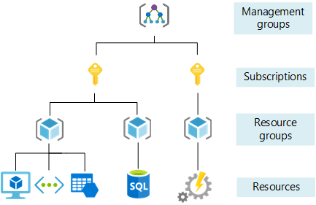

**2. How to Create an Azure Active Directory (Azure AD) Tenant**

**Step 1: Log in to Azure Portal**

* Open [https://portal.azure.com](https://portal.azure.com/) in your browser.
* Sign in with your Microsoft or Azure account.

**Step 2: Navigate to Azure Active Directory**

* In the left sidebar, select **Azure Active Directory**.
* This opens your current directory (tenant) overview.

**Step 3: Create a New Tenant**

* On the Azure AD overview page, click **Manage tenants** at the top right.
* Click the **+ Create** button to start creating a new tenant.

**Step 4: Fill in Tenant Details**

* Select **Azure Active Directory** as the tenant type.
* Enter the **Organization name** – your company or organization name.
* Set the **Initial domain name** (will end with .onmicrosoft.com).
* Choose the **Country or region** where your organization is based.

**Step 5: Create the Tenant**

* Click **Create**. Azure will provision a new Azure AD tenant.
* This new tenant acts as a new organization boundary for identity and access management.

**Step 6: Switch Between Tenants**

* Click your profile icon in the top-right corner of the Azure portal.
* Select **Switch Directory** to change between multiple tenants you belong to.

**3. How to Create an Azure DevOps Organization**

**Step 1: Visit Azure DevOps Website**

* Go to <https://dev.azure.com/>.
* Sign in with your Microsoft or Azure account.

**Step 2: Start Creating an Organization**

* Click the **New Organization** button on the home page.

**Step 3: Provide Organization Details**

* Enter a unique **Organization name**.
* Choose the **Region** where your data will be stored (important for compliance and latency).

**Step 4: Complete Organization Creation**

* Click **Continue**. Azure DevOps will create the organization.

**Step 5: Create Projects and Add Users**

* Inside your new organization, create one or more projects.
* Invite team members and assign roles and permissions as needed.

**4. Differences Between Azure AD Tenant and Azure DevOps Organization**

| **Feature** | **Azure Active Directory Tenant** | **Azure DevOps Organization** |
| --- | --- | --- |
| Purpose | Manage users, groups, and authentication | Manage DevOps workflows: repos, pipelines, boards |
| Creation Location | Azure Portal | Azure DevOps portal |
| Main Use | Identity and access management | Software development lifecycle management |
| Scope | Enterprise-wide user and resource control | Projects and source control organization |

**5. Why Create These Organizations?**

* **Azure AD Tenant**: Needed to manage who can access your Azure resources, set policies, and secure your cloud environment.
* **Azure DevOps Organization**: Needed to collaborate on code, automate builds and deployments, and manage software projects efficiently.